**EVALUATION OF NACA 2408 AIRFOIL AS A 2D GLIDER WING**

Paul Yuska, AE516, 1/27/2020

**Introduction:**

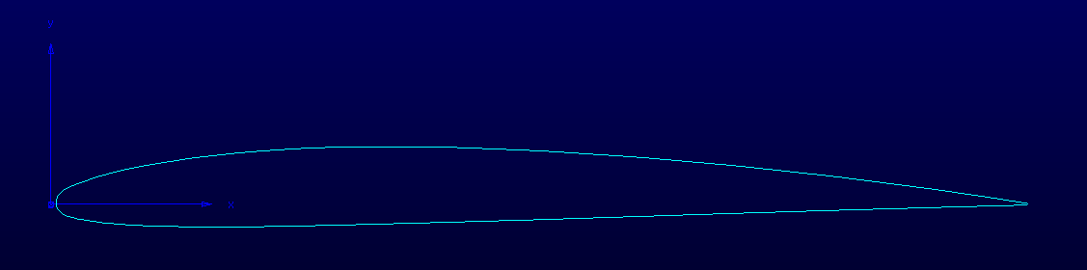

Figure 1: Airfoil Shape for NACA 2408

Table 1: Freestream Conditions

|  |  |
| --- | --- |
| Pressure | 1 atm / 101,300 Pa |
| Velocity | 17.88 m/s |
| Density | 1.225 kg/m3 |
| Temperature | 298 K |
| Reynolds Number | 1,000,000 |

Table 2: XFOIL Estimates for Max Cl and Cl/Cd at Re = 1e6

|  |  |  |
| --- | --- | --- |
| Max Cl | 12.75 deg | 1.3714 |
| Max Cl/Cd | 2.5 deg | 86.812 |

**Methodology:**

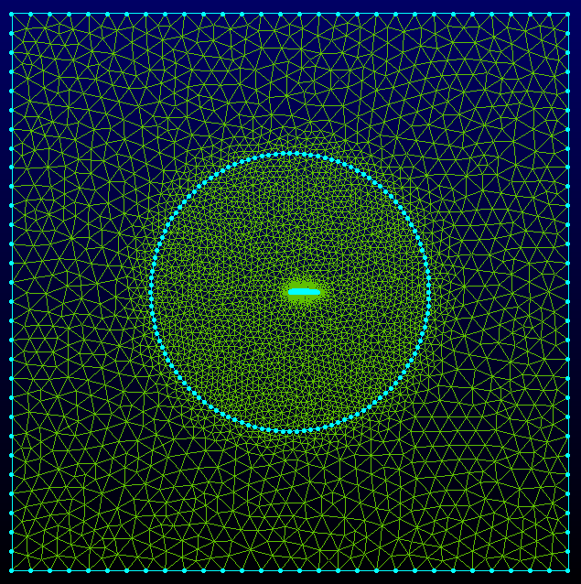

Figure 2: Computational Domain Grid

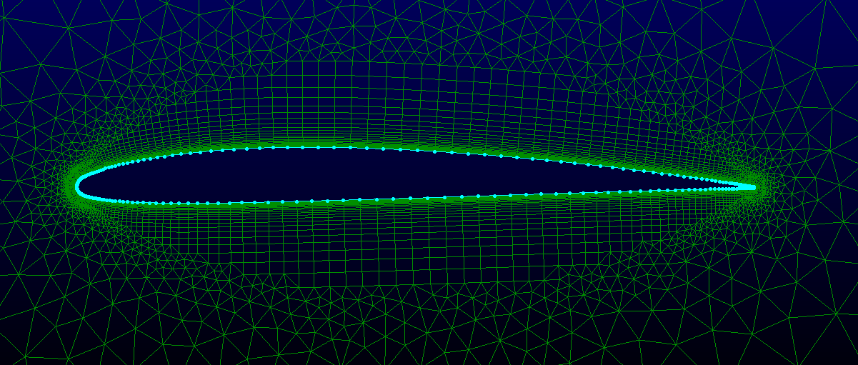

Figure 3: Near-Field Grid

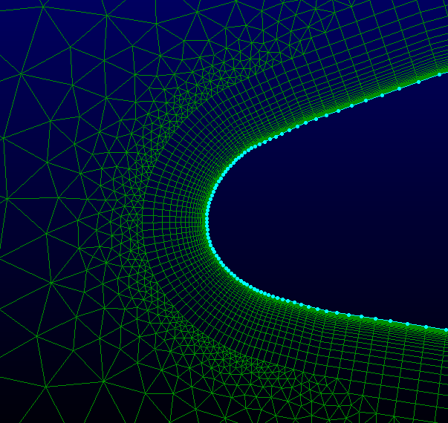

Figure 4: Leading Edge Grid

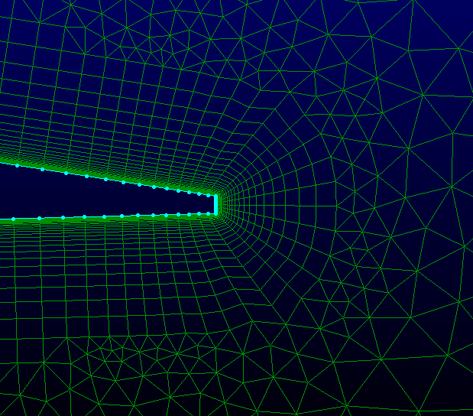

Figure 5: Trailing Edge Grid

Table 3: Grid Specifics

|  |  |
| --- | --- |
| Cell Count | 21,234 |
| Normal-to-Wall Spacing | 1e-5 m |
| Submodels Chosen | k-ω, SST |
| Numerical Scheme | SIMPLE |
| Spatial Accuracy | 2nd Order |

Table 4: Boundary Conditions

|  |  |
| --- | --- |
| Airfoil Surface | Wall, no-slip |
| Tunnel Floor/Ceiling | Symmetry |
| Inlet | Velocity inlet |
| Outlet | Pressure outlet |

Table 5: Reference Values

|  |  |
| --- | --- |
| Area | 1 m2 |
| Density | 1.225 kg/m3 |
| Depth | 1 m |
| Enthalpy | 0 J/kg |
| Length | 1 m |
| Pressure | 0 Pa |
| Temperature | 298 K |
| Velocity | 17.88 m/s |
| Viscosity | 1.7894e-5 kg/m-s |
| Gamma | 1.4 |

**Results:**

|  |  |  |  |  |  |  |  |
| --- | --- | --- | --- | --- | --- | --- | --- |
| AoA (deg) | Cl | Cd | Cl/Cd | Cm | Lift (N) | Drag (N) | Mom (N-m) |
| -2.25 | -0.0230 | 0.0101 | -2.3278 | 0.0492 | -4.5893 | 1.9715 | 9.6441 |
| 0 | 0.2151 | 0.0101 | 21.194 | 0.0489 | 42.122 | 1.9875 | 9.5842 |
| 3.5 | 0.5823 | 0.0121 | 48.317 | 0.0478 | 114.04 | 2.3601 | 9.3606 |
| 7 | 0.9359 | 0.0166 | 56.518 | 0.0454 | 183.26 | 3.2425 | 8.8981 |
| 10.5 | 1.2618 | 0.0261 | 48.344 | 0.0407 | 247.09 | 5.1110 | 7.9666 |
| 12.5 | 1.3882 | 0.0378 | 36.699 | 0.0370 | 271.83 | 7.4070 | 7.2373 |

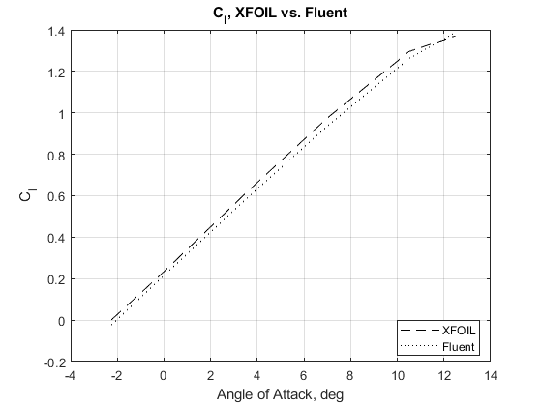

Figure 6: Lift coefficient comparison.

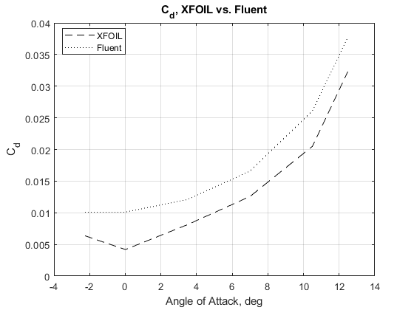

Figure 7: Drag coefficient comparison

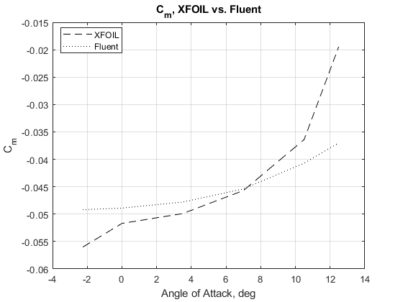

Figure 8: Moment coefficient comparison.

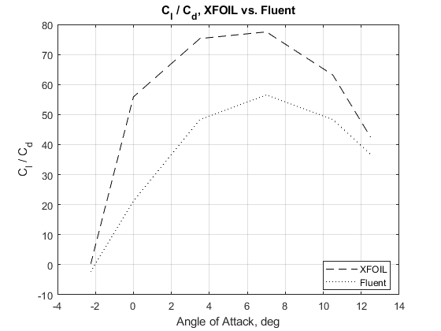

Figure 9: Coefficient ratio comparison.

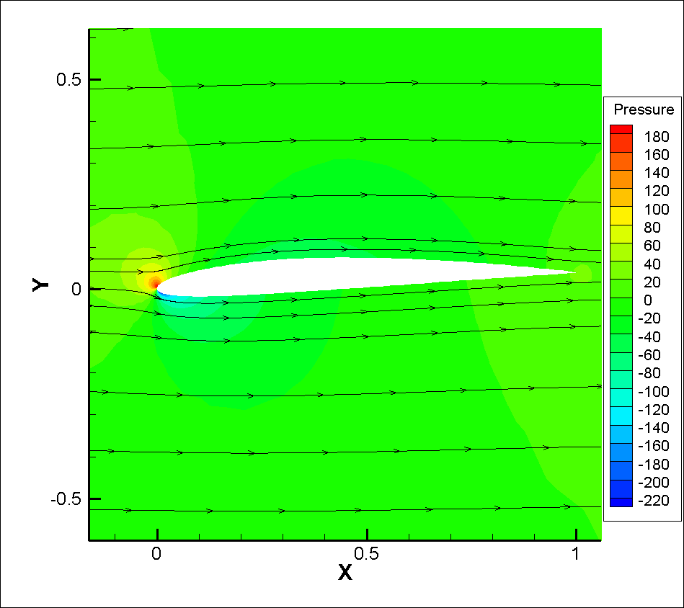

Figure 10: Zero-lift (-2.25 deg AoA) pressure contour and streamlines.

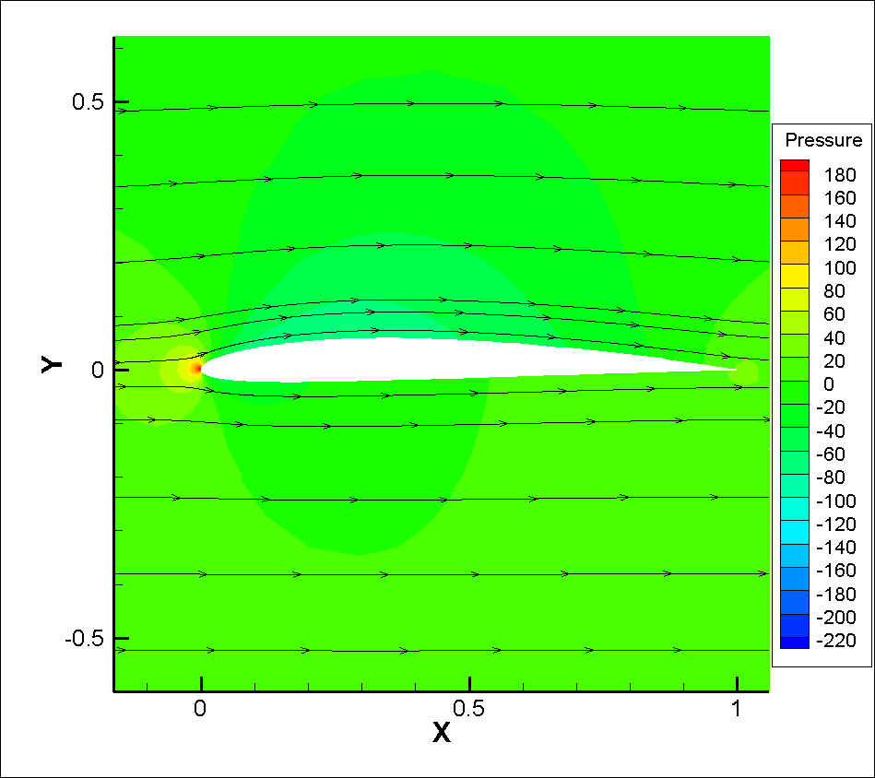

Figure 11: 0 deg AoA pressure contours and streamlines.

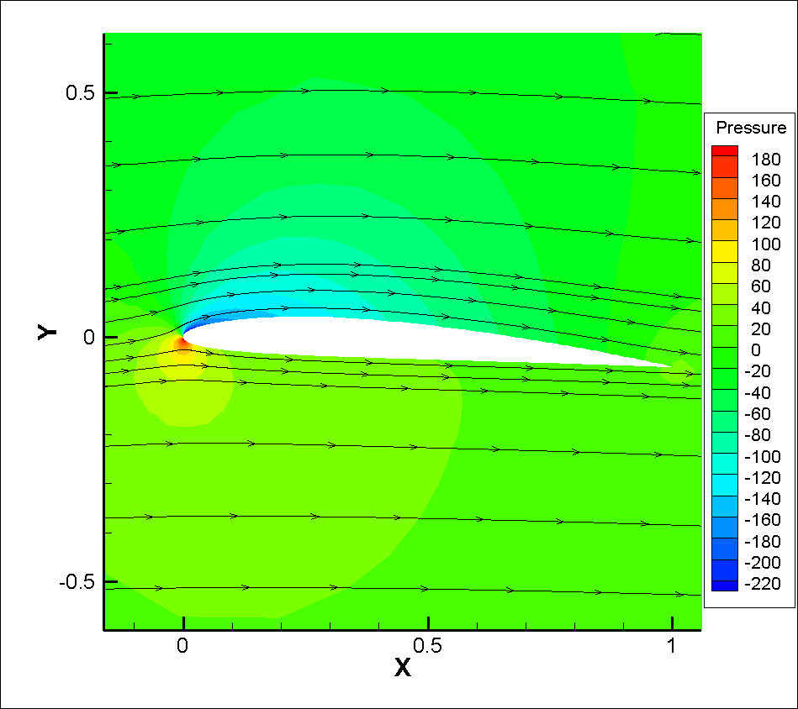

Figure 12: 3.5 deg AoA pressure contours and streamlines.

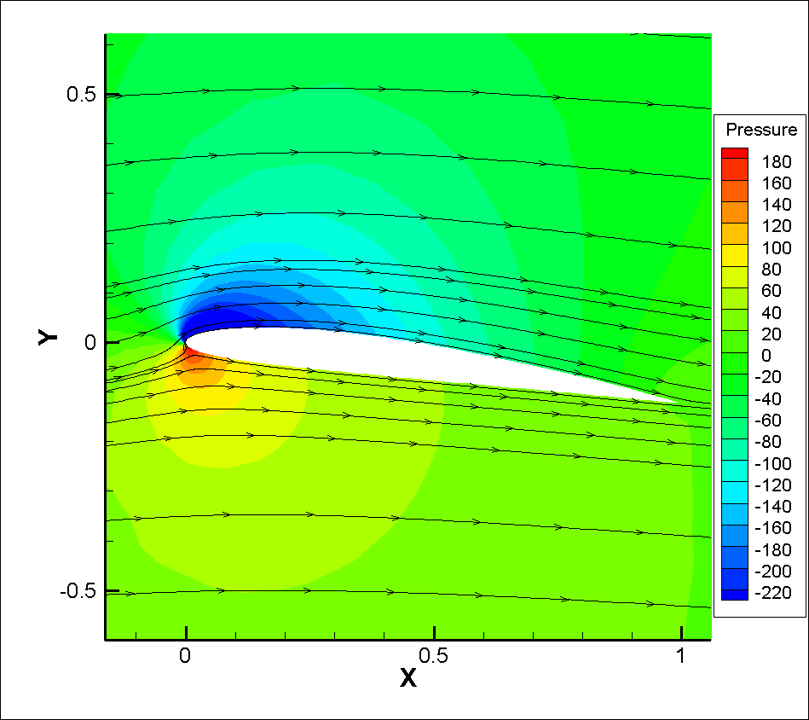

Figure 13: 7 deg AoA pressure contours and streamlines.

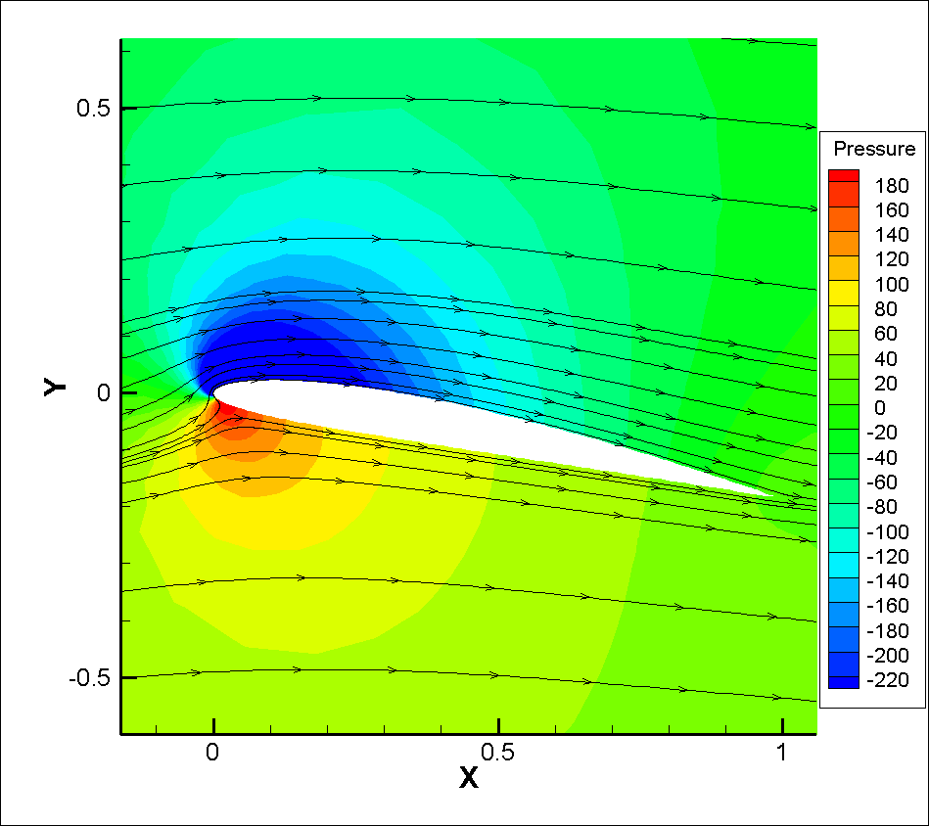

Figure 14: 10.5 deg AoA pressure contours and streamlines.

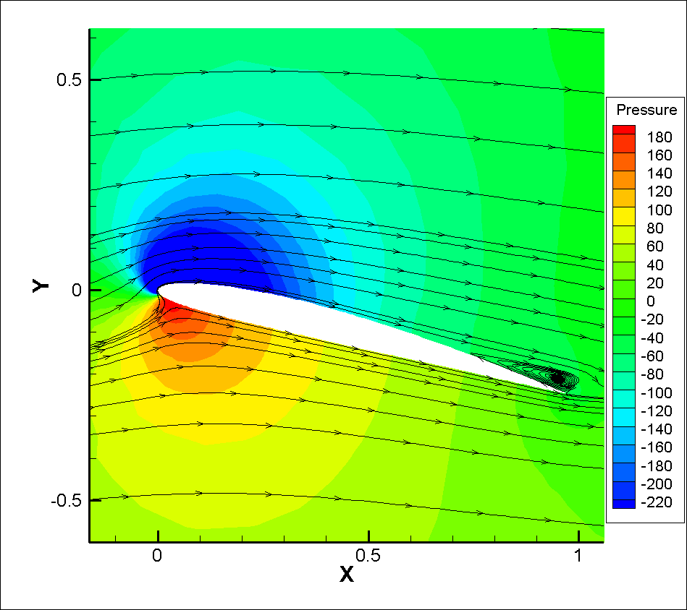

Figure 15: Max lift (12.5 deg AoA) pressure contours and streamlines.

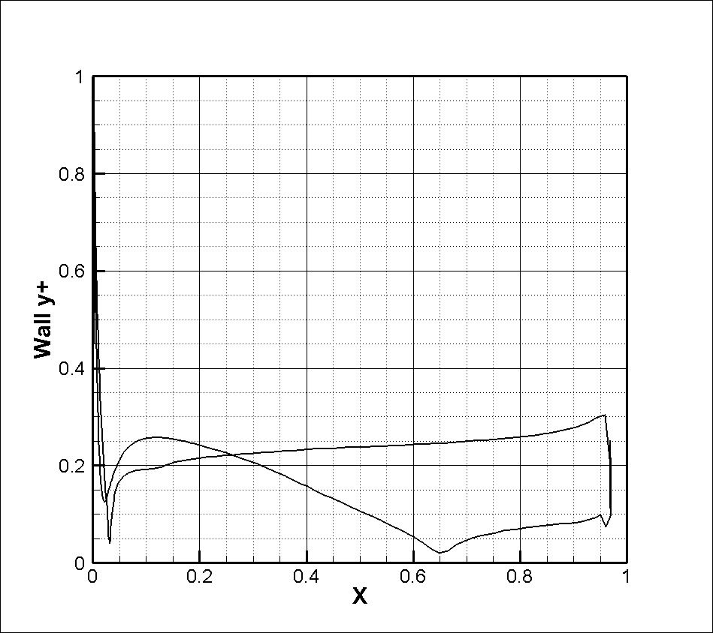

Figure 16: Wall y+ along airfoil.

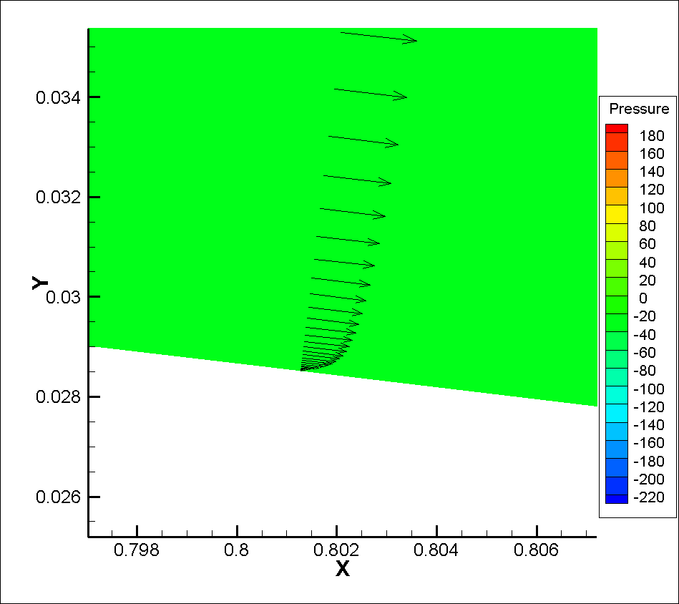

Figure 17: Boundary layer development toward TE of airfoil.

**Discussion:**

The XFOIL and Fluent lift coefficient curves match quite well (<10% difference). The drag, moment, and ratio of coefficients do not match as closely. This is likely due to differences in turbulence or viscosity models for the flow. NACA 2408 is a thin airfoil, and therefore does not create much form drag; the remaining sources of drag are induced drag, which, being a function of lift, should be quite accurate, and viscous drag. Differences in how XFOIL calculates turbulence will result in significant differences in resultant drag.

**Appendix: Convergence Histories**

-2.2 deg AoA:

0 deg AoA:

3.5 deg AoA

7 deg AoA:

10.5 deg AoA:

12.5 deg AoA: